# Meter Reading Application Run Instructions

## Database Setup

Open MeterReadingsApp.sln located in \SurajEnsekTest\MeterReadingsApp via Microsoft Visual Studio (2022).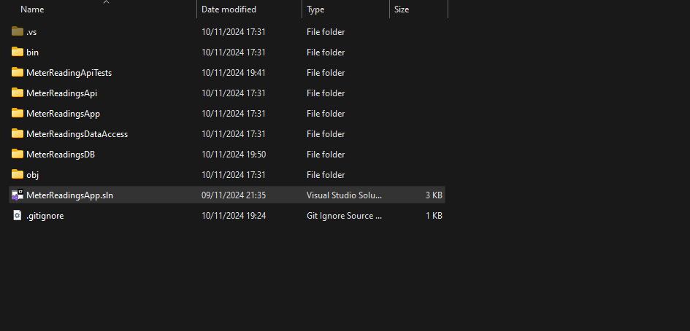

In the Solution Explorer locate and open Script.PostDeployment1.sql.

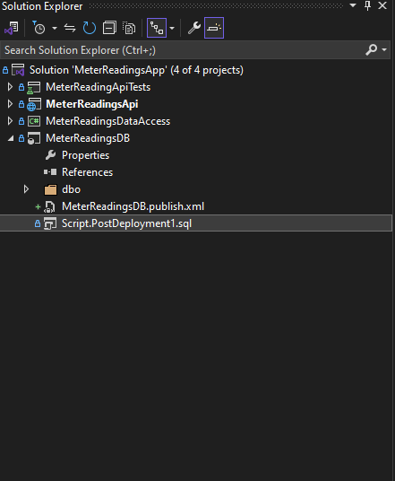

After FROM between the single quotations add the appropriate file path for Test_Account.csv file and save file.

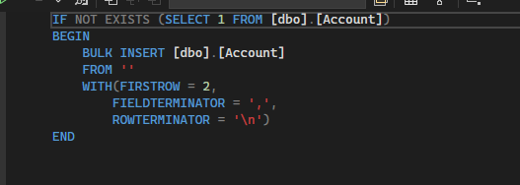

Right-click on MeterReadingsDB and click Publish.

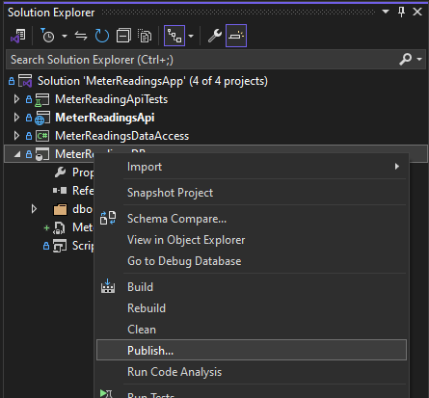

Point the database connection to localdb (or wherever appropriate) and click Publish.

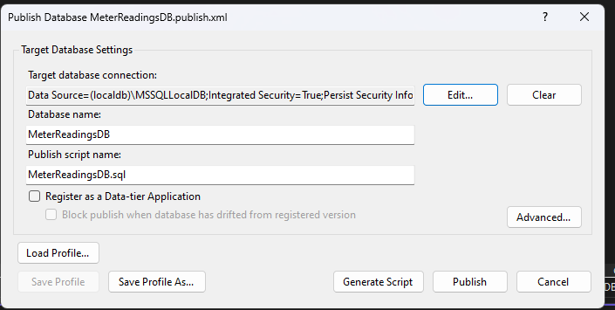

View SQL Server Object Explorer. New MeterReadingsDB should have been created and Account table populated with content of csv file.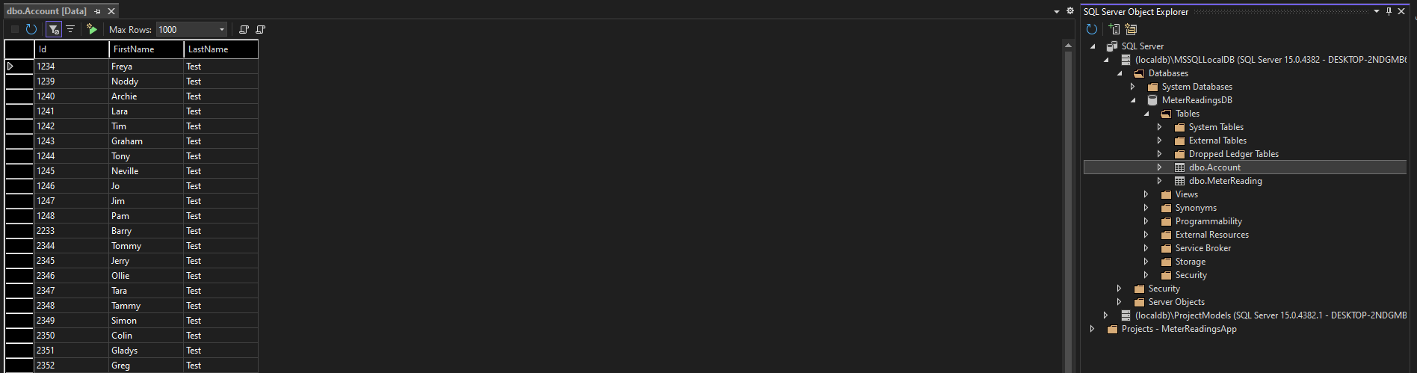

Locate appsetting.json file in the MeterReadingsApi project and ensure the “Default” connection is set to the connection string of your newly created database.

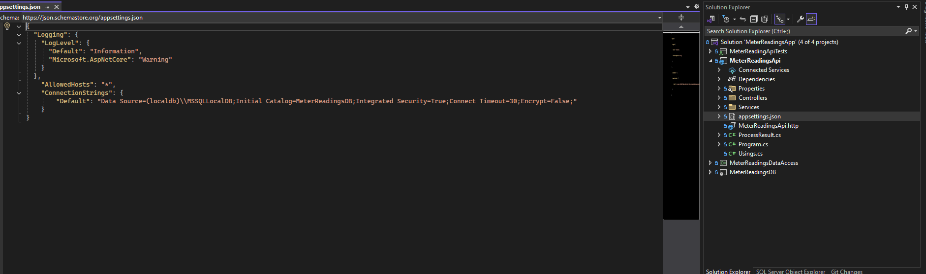

## Run Web API with Swagger

Run application via IIS Express by selection either green arrow.

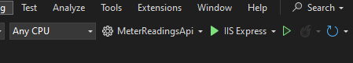

This will launch the Swagger page for the API containing the single endpoint (Api can be tested here by uploading the appropriate csv file).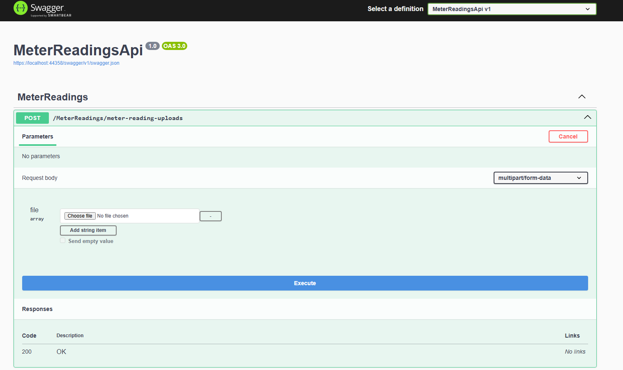

## Run Angular Web Application

Locate and open MeterReadingsAngularApp folder in appropriate editor (Visual Studio Code).

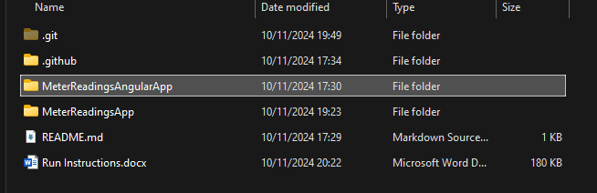

In the app.component.ts file ensure on line 56 the URL is correctly set to your local instance of the MeterReadingsApi (Note: Not representative of a production app, URL would ideally be config driven).

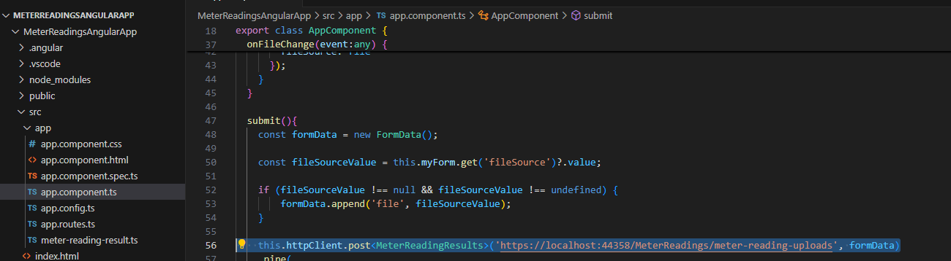

In the terminal navigate to the next MeterReadingsAngularApp folder and run ng serve (I used latest Angular cli version).

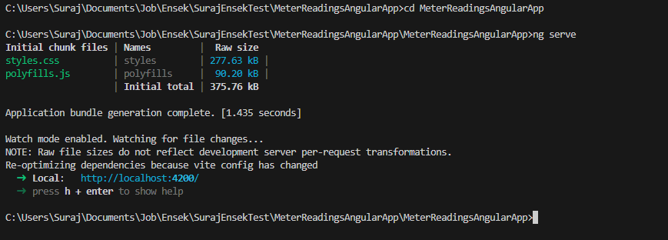

Open URL provided in terminal (http://localhost:4200/) in browser, file uploader application website should load.

Ensure local instance of the MeterReadingsApi is still running and application can be tested here by uploading the appropriate csv file.

